**North South University**

Department of Electrical and Computer Engineering



**Course Code: CSE438**

**Section: 2**

**Faculty Advisor:**

Dr. Shamim Al Mamun

**Name & ID:**

Shoyeb Bin Babor 1721435643

MD. Mehedi Hasan Bhuiyan Nipu 1911870642

Ridwan Shikder 1912089642

Sazal kumar Pramanik 1931244042

**Introduction:** This scenario for a college network involves creating a topology for a LAN (Local Area Network) where multiple machines from various departments are set up so they may interact and communicate with one another by exchanging data. It promotes communication between multiple departments to establish a networking environment for a college that connects different departments.

**Tools:**

* Cisco packet tracer

Cisco Packet tracer: The capacity to build, configure, and debug networks is essential in computer networks. Cisco Systems' Cisco Packet Tracer is a potent network simulation tool that enables IT professionals, network administrators, and students to explore and test different network topologies and protocols in a virtual setting. This technology has become crucial in networking education for teaching, learning, and evaluating network ideas. The capability of the Cisco Packet Tracer to replicate network protocols and services is one of its main advantages. Users can configure routing protocols. Additionally, Cisco Packet Tracer provides several tools and capabilities that improve the educational process.

**Components/ equipment:**

* End Device:

1. PC
2. Printer
3. Laptop

* Miscellaneous:

1. Switch

* Network Device:

1. PT-Router

* Connection:

1. We are using an Automatic connection here for our convenience.

**Components Details:**

**Switch:** Switches are networking devices that operate at the OSI model's layer two or data connection layer. They establish connections between networked devices and employ packet switching to transmit, receive, or forward data packets or frames over the network. There are several ports on a switch where computers may be connected. A network switch evaluates the destination address of each data frame that enters one of its ports, runs any necessary checks, and then transmits the frame to the appropriate device or devices. It enables broadcast, multicast, and unicast communications.

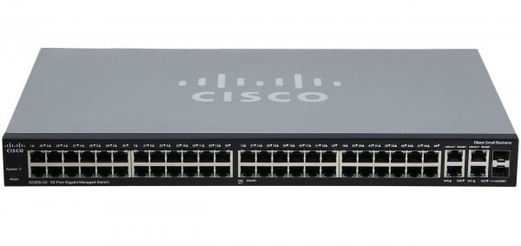

**Router: A router can connect one or more packet-switched networks or subnetworks**. It manages traffic across these networks by forwarding data packets to their intended IP addresses. It enables several devices to share a single Internet connection for its two primary purposes.

There are many kinds of routers, but most transfer data between LANs (local area networks) and WANs. A LAN is a collection of linked devices confined to a particular region. Typically, a LAN needs just one router.

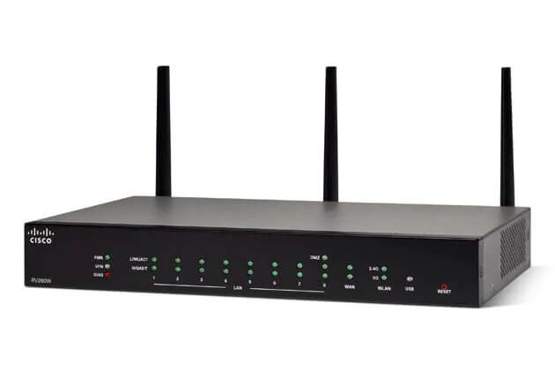

**Server:** A server is a piece of hardware or software that processes requests sent over a network and answers to them.

A client is a device that submits a request and waits for a response from the server. Servers manage network resources. For instance, a user could install a server to handle print jobs, transmit and receive email, or host a website. They are very adept at doing complex computations. Some servers, also called dedicated servers, are devoted to a particular job. In contrast, many servers nowadays are shared servers that handle tasks like email, DNS, FTP, and even websites when acting as web servers.

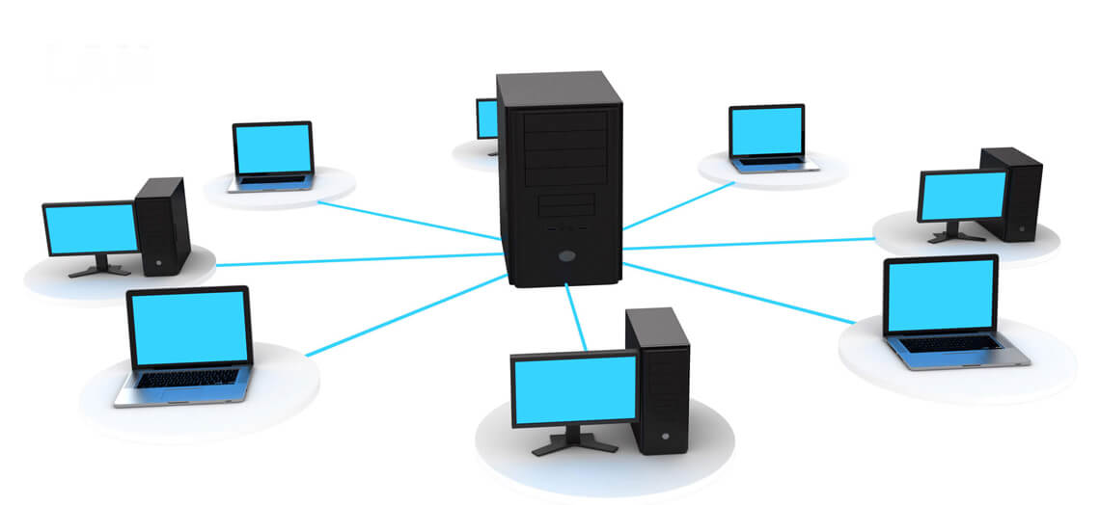

**Desktop Computer (PC):** Unlike high-performance computers, often designated for IT professionals to maintain servers, PCs are multifunctional machines designed for individual end users.

Commercial Operating Systems (OS), commercial software programs, freeware, and open-source software are commonly used to power PCs.

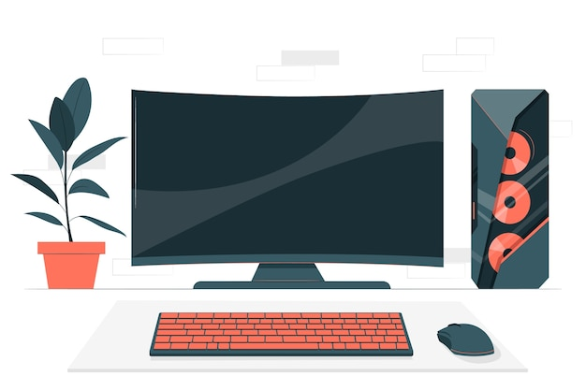

**Laptop:** The term "laptop" or "notebook" refers to a portable computer used in various settings. They come with a screen, keyboard, and a mouse-replacing trackpad or trackball. Laptops contain a battery that enables them to run without being hooked to a power outlet because they are designed to be used on the road. The power adapter that lets laptops utilize electricity from an outlet and recharges the battery is also included.



**Cable:** The network's whole cabling system is the most crucial component. Without linking one network component to another, the network is essentially worthless.

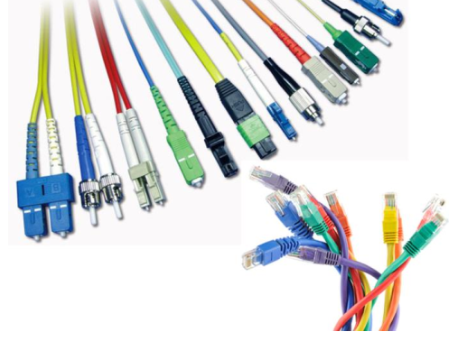

**Building Network Description:**

First, we have to build the architecture of our network system. We have to assign the PC and Printer for particular workstations.

For example, we have assigned four pc and one printer in our Internet lab with a PT-switch. We have been working with the IP dedicated to the Internet lab, 128.168.0.0. To assign the Ip to our pc, we have to configure it. First, we must choose the pc and then go to the desktop setting. After that, we will assign the static IP address. After assigning the IP, we will get the subnet automatically for that IP address. We set the DNS server, which we are using in our server room DNS.

For the printer, we also have to set the configuration. We have to put the default gateway and the DNS server.

For the switch, we have to use some extra modules PT-SWITCH-NM-1CFE. Here we are using an extra four of them.

Now for the server room. We have to work with the Server-PT FTP. Here also we need to configure the desktop setting and config the IP. First, we have to set the IP which we are assigned to. And for the default gateway, we are using 1.0.0.1. We follow the exact procedure to config the other server in our network.

Then comes the router setting part. For Router1, we have to config the router connection. In the router config, we must toggle the port status to on. After that, we will Change the IPv4 address with the server room IP, 1.0.0.1, and the subnet in the IP configuration setting. Then we have to similarly change the IP address for the Internet lab room connection. Here the IP address we set is 128.168.0.1.

After connecting the router with the connection wire, we must configure the RIP. This means to which network address our router will connect. For Router1, the network addresses are 1.0.0.0, 20.0.0.0, and 128.168.0.0.

With Router 2, we have connected the principal room and the other. The dedicated IP for those is 192.168.4.1 for the principal room and 192.168.3.1 for others. The network addresses we used for this router are 10.0.0.0, 20.0.0.0,192.168.3.0 and 192.168.4.0

Again, for router 3, we have toggled the router port status on and assigned the routing IP, connected to the computer department (192.168.2.0) and IT department (192.168.1.0).

**IP Addressing Plan:**

|  |  |
| --- | --- |
| **Internet Lab** | **128.168.0.0** |
| PC-PT PC0 | 128.168.0.2 |
| PC-PT PC1 | 128.168.0.3 |
| PC-PT PC2 | 128.168.0.4 |
| PC-PT PC3 | 128.168.0.5 |
| Printer-PT Printer0 | 128.168.0.6 |
|  |  |
|  |  |
| **Computer Department** | **192.168.2.0** |
| PC-PT CS HOD CABIN | 192.168.2.2 |
| PC-PT CS LAB1 | 192.168.2.3 |
| PC-PT CS LAB2 | 192.168.2.4 |
| PC-PT CS LAB3 | 192.168.2.5 |
| PC-PT CS LAB4 | 192.168.2.6 |
| Printer-PT Printer1 | 192.168.2.7 |
|  |  |

|  |  |
| --- | --- |
| **IT Department** | **192.168.1.0** |
| PC-PT HOD CABIN | 192.168.1.2 |
| PC-PT IT LAB1 | 192.168.1.3 |
| PC-PT IT LAB2 | 192.168.1.4 |
| PC-PT IT LAB3 | 192.168.1.5 |
| PC-PT IT LAB4 | 192.168.1.6 |
| Printer-PT Printer2 | 192.168.1.7 |
|  |  |

|  |  |
| --- | --- |
| **Server Room** | **1.0.0.0** |
| PC-PT PC4 | 1.0.0.5 |
| Server-PT FTP | 1.0.0.4 |
| Server-PT WEB | 1.0.0.3 |
| Server-PT DNS | 1.0.0.2 |

|  |  |
| --- | --- |
| **Other** | **192.168.3.0** |
| PC-PT Office | 192.168.3.2 |
| PC-PT Exam Cell | 192.168.3.3 |
| Printer-PT Printer3 | 192.168.3.6 |
| PC-PT TPO | 192.168.3.5 |
| Printer-PT Printer4 | 192.168.3.7 |
| PC-PT Enqirey | 192.168.3.4 |
| Printer-PT Printer5 | 192.168.3.8 |

|  |  |
| --- | --- |
| **Principle Room** | **192.168.4.0** |
| PC-PT PC19 | 192.168.4.2 |
| Laptop-PT Laptop0 | 192.168.4.3 |

**Image Sample:**

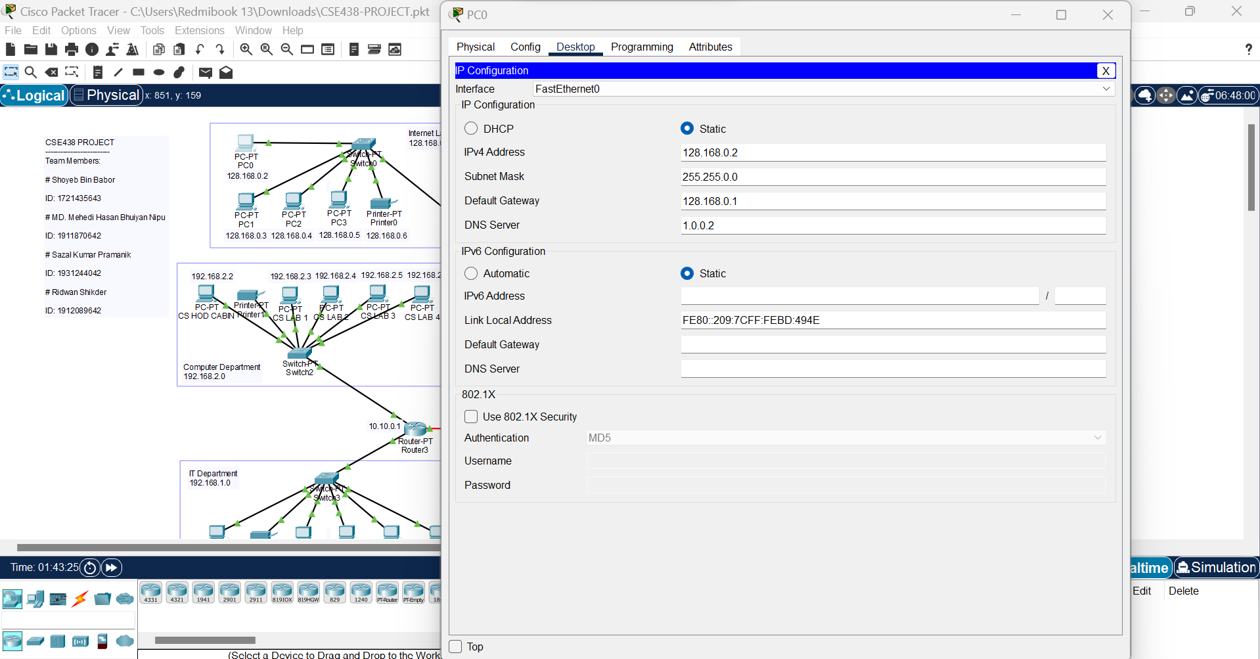

Fig: Pc Config (IP Setting, Default gateway, and DNS server Setting)

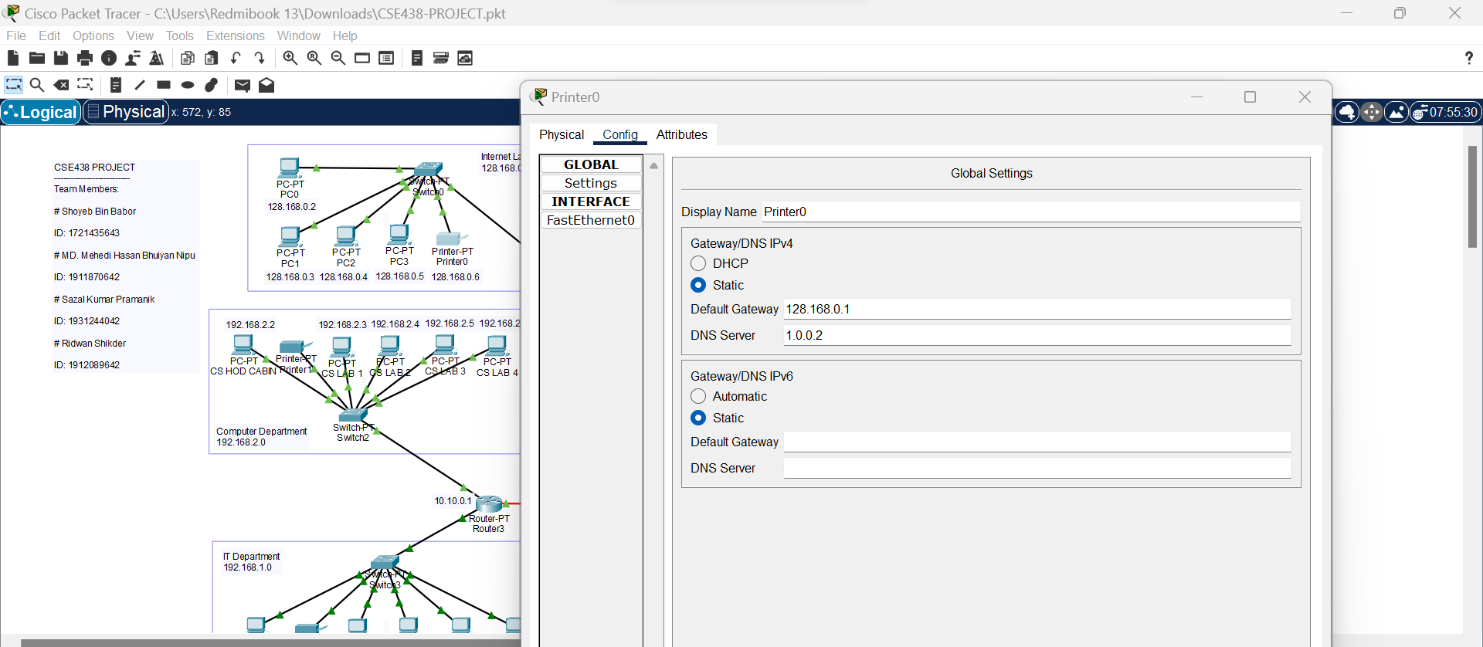

Fig: Printer Config ( Default gateway and DNS server Setting)

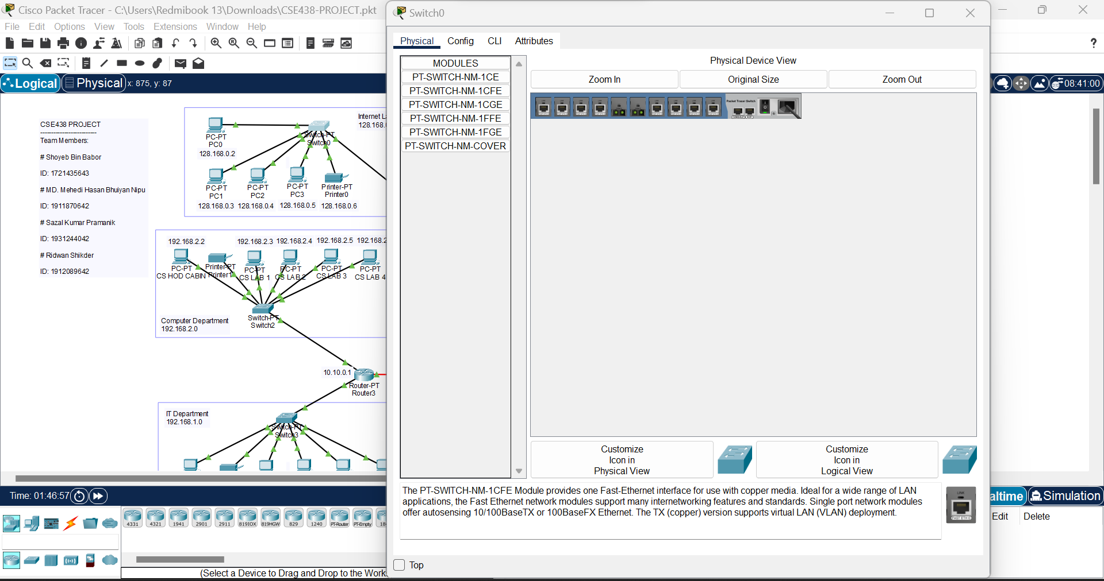

Fig: Switch Setting

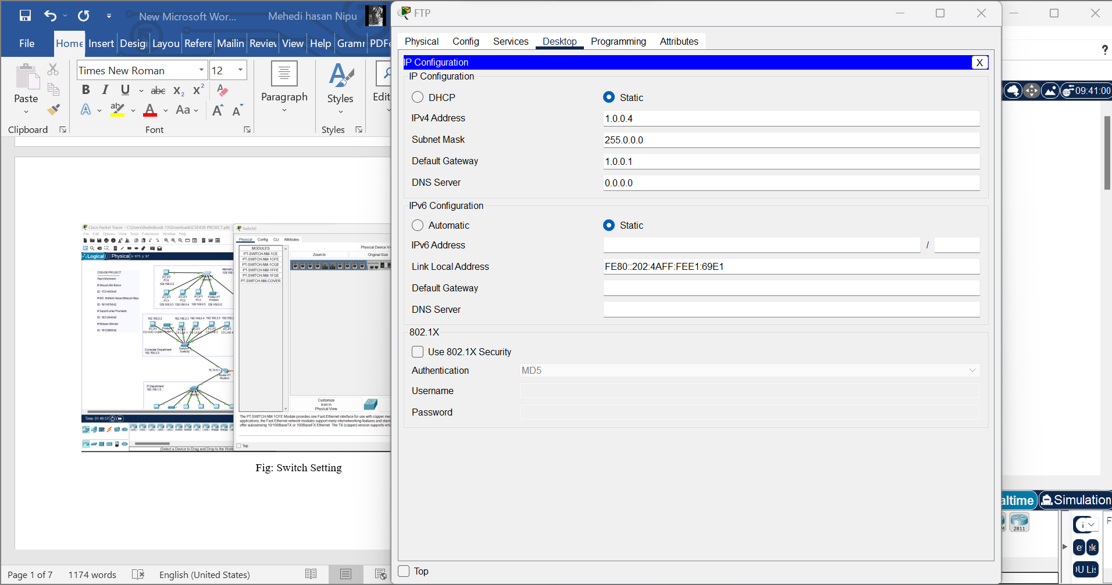

Fig: Server Config FTP (IP Setting, Default gateway, and DNS server Setting)

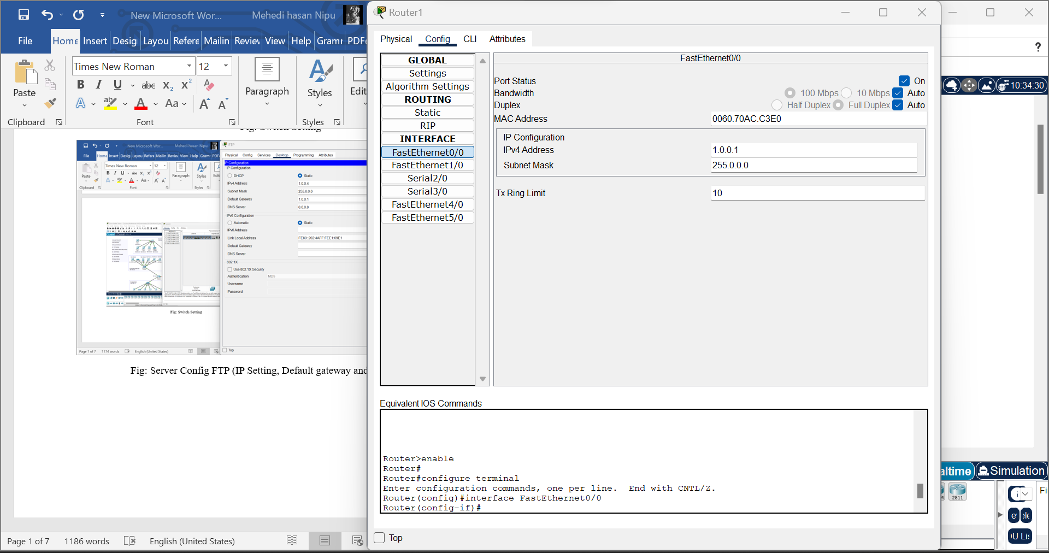

Fig: Router Config (Ip config)

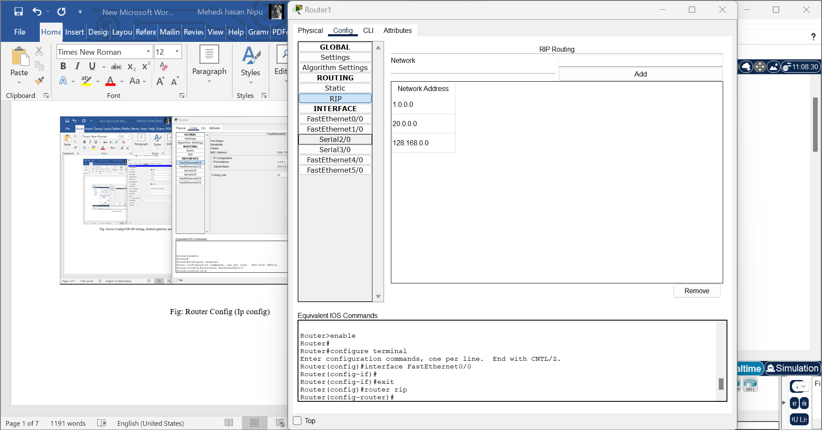

Fig: Router Config ( Connected network Address)

**Risk assessment of our network:**

* Firstly, we will try to continue monitoring our network.
* After, we must find the hazard present in our network.
* After finding the hazard, we must analyze which is more dangerous or weak.
* Find the way to handle the existing hazards.
* When we find the way, we try to mitigate that hazard and record everything.
* After that, test our network, which is the final review.

**Way to mitigate the threats:**

* Firstly, always try to enable firewall authentication, which protects the system from external threats.
* Constantly monitor the networks continuously or regularly; if we feel any abnormal activity, we must take action before any harm.
* Always use a strong password to access any resource from the network; that password must include upper and lower case and some special characters.
* The defense must be ready to get prevent threats.
* The system must be up to date according to the requirements of the network.
* Must perform the security assessment to get prevent unauthorized access.

**Conclusion:** This report describes how our network system builds and how the system works. Thus, we have studied all the components like routers, switches, etc., and services like DNS, DHCP, FTP, etc., and successfully designed a College Computer Network using Cisco Packet Tracer.

**Thank you**